Printing Quotes with Metrix Dimensions

The N-K-1 Control Parameters named BoxDesUm, QuoPrint and JobCardC are used to print metric dimensions on the box design and business forms. The Xprint quote format was modified to print metric dimensions. The estimate must be entered in imperial inches with the inches to the left of the decimal point and the 1/16th  of an inch to the right of the decimal. For example 10.01 is 10-1/16th inches, 10.02 is 10-2/16th inches, 10.03 is 10-3/16th inches, 10.04 is 10-4/16th inches, etc. On the Estimate screen below, the METRIC field must be set to Yes, then the program will convert the inches into metric when printing and emailing the quote form and job ticket forms such as CapCity,

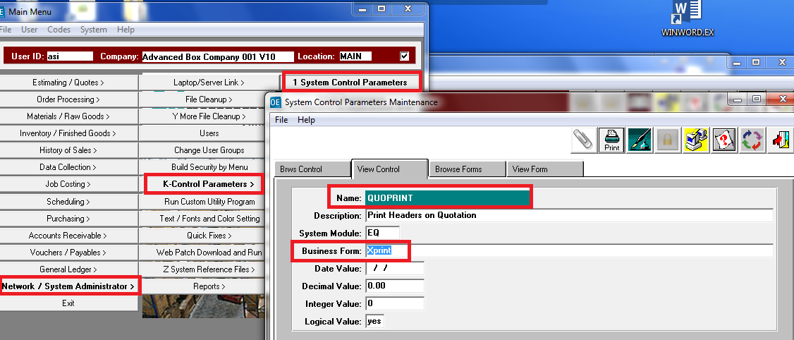

N-K-1 BoxDesUM for Displaying and Printing Metric

N-K-1 BOXDESUM = Box Design Unit of Measure.   
The estimates box design and scoring dimensions will display in metric for corrugated plant job tickets, folding carton job tickets, folding carton estimates, quotes and the estimates box design folder. The box design will print the panel sizes including scoring allowance in metric, inches or both depending on the character value selection. Please note, the dimensions are always entered in inches.

CHARACTER VALUE: = MM  
The estimate dimensions entered in inches will always convert to metric millimeter on the box design dimensions, then print on business forms such as the job ticket in metric.

CHARACTER VALUE: = BOTH  
The Metric Field on the Estimate’s SPEC folder dictates printing metric or imperial. Estimate METRIC = YES, this logic will print metric dimensions. Metric field = NO, then the dimensions would print in inches.

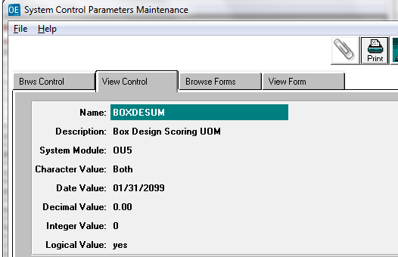

Estimate Box Design Tab

Notice the imperial dimension on the above estimate are Joint = 1.08 x Length = 12.04 x Widt = 10.08 x Depth = 20.12. This is stored in the database as 1.05 x 12.25 x 10.50 x 20.75.

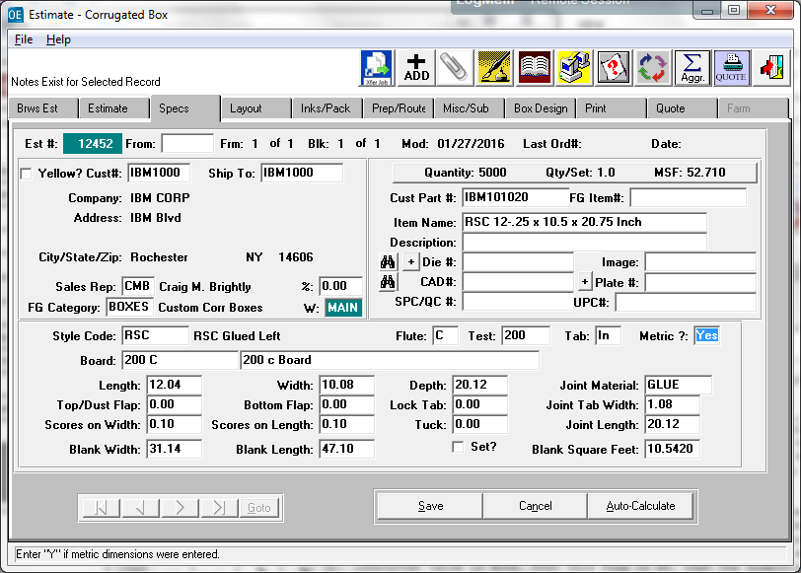

Displaying and Printing in Metrix Dimensions  
**The RSC Width panel formula is( .5W+.02) + (D + .06) + (.5W +.02).**   
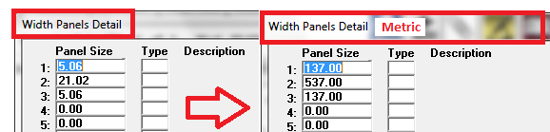

**The RSC Length panels formula is J + .00) + (W+.02) + (L + .03) + (W +.03) + (L + .02)**

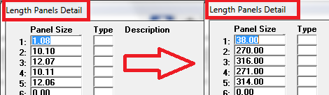

**The Estimate Box Dimensions will display in Metric and Print in Metric on the Job Ticket.**

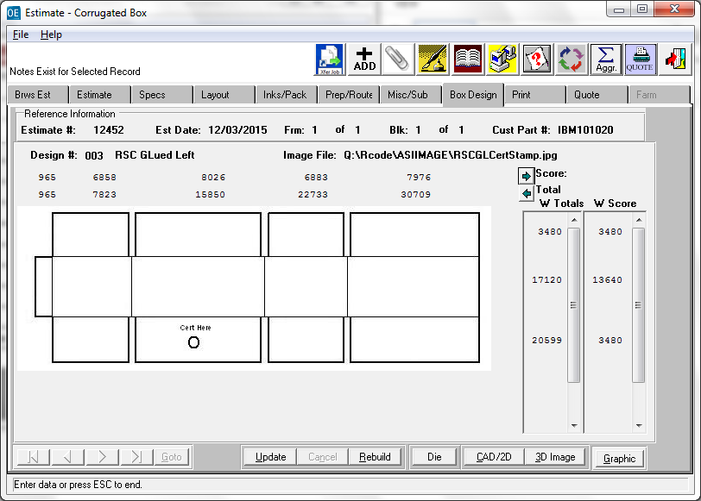

QUOTE FORM IN METRIC

The Description can be typed however the estimator desires. To be consistent the item description should be entered in metric.

